ARTES 4.0 Technologies and Products
Proposal Part 4
Management Proposal
Proposal title
Proposal Reference: reference number

Notes for the use of this template (to be removed from the Proposal)
This document contains requirements gathered in annex. For convenience, they can be accessed via hyperlinks that are located at the beginning of the section they relate to. These requirements must be taken into account when completing the Proposal.
Material presented in this plain style must not be removed nor modified, unless stated otherwise by an explanatory note.
Parts highlighted in yellow may or may not need to be filled in, depending on the scope of the proposal (please refer to the related explanatory notes to determine if they apply or not).
Text in red font must be modified and/or completed by the Tenderer for the proposed activity (this supplementary information should be presented in plain typeface, i.e. not red, in the final version of the proposal).
Text in blue italics is used for explanatory notes and guidance to help you to develop the proposal content. They should be removed from the final document before submission.

A single Management Proposal shall be included covering the Development Phases (Definition and Technology and/or Product and Demonstration) for which support is being requested under the ARTES 4.0 Technologies and Products Call for Proposals.

Use of this Proposal Template is mandatory. The Tenderer shall not change the structure of this Proposal Template (i.e. the table of contents must remain unchanged) and adhere to its guidelines and requirements. However, the format and lay-out can be modified, e.g. to be in-line with the Tenderer’s corporate identity.

Table of Contents
1 Entity Outline and Organisation 3
2 Entity Capabilities 3
3 Relevant Experience of the Entity / Entities 4
4 Relevant Development Activities 4
5 Project Team and Structure of Project Organisation 5
6 Project Manager 5
7 Key Personnel and Their Roles 5
8 Qualifications and Experience 6
9 Time Allocation to the Project 6
10 Facilities to be used for the Work Proposed 6
11 Management Plan 8
12 Product Assurance Plan / Quality Plan 8
13 Security Management Plan(s) 8
Annex 1: Curricula Vitae of the Key Personnel 10
Annex 2: Requirements for Proposal Content 12

Entity Outline and Organisation
The following table is a summary of the Bidding Team, showing the number of employees, and the annual turnover for each consortium member.
Entity information
Entity | Number of Employees | Annual Turnover
Name of Tenderer | … | …
Name of Subcontractor 1 | … | …
Name of Subcontractor 2 | … | …
… | … | …
Provide the following information for each member of the project consortium
(e.g. in dedicated sub-sections per entity)
The organisational structure of entity name is shown in the figure below. The positions of the project’s key personnel are indicated in the figure.
Insert an organisational chart showing the positions occupied by each of the key personnel for the entity concerned
Include the following statement if applicable
Further information on the entity can be found in document reference (e.g. a standard entity presentation), which is attached to the proposal.

Entity Capabilities
Provide the following information for each member of the project consortium
A presentation of entity name’s capabilities, expertise and products in the satellite telecommunication market, and in other relevant markets, is provided in document reference, a copy of which is attached to the proposal.
or
(delete the inapplicable paragraph)
A summary presentation of entity name’s capabilities, expertise and products in the satellite telecommunication market, and in other relevant markets, is provided in the paragraphs below. ……

Relevant Experience of the Entity / Entities
The following table summarises the specific experience of each member of the project consortium that is relevant to the work to be performed.
Experience relevant to the work to be performed
Project Team Template | Year | Mission/ Project | Subsystem/ Unit | Work Performed | Relevance to the Proposed Work
Name of Tenderer | … | … | … | … | …
Name of Tenderer | … | … | … | … | …
Name of Subcontractor 1 | … | … | … | … | …
Name of Subcontractor 1 | … | … | … | … | …
Name of Subcontractor 2 | … | … | … | … | …
Name of Subcontractor 2 | … | … | … | … | …

Relevant Development Activities
This section refers to past, present or future activities that are not directly linked to the proposed development but may be of relevance (i.e. demonstrating similar technical expertise). Consequently, activities already listed in section 6 of Part 3A must not be listed here.
The members of the Bidding Team have no involvement, past, present or future, in other ESA, public or industrial activities that are relevant to the proposed activity.
or
(delete the inapplicable paragraph)
The following planned/running/completed development activities are considered relevant in the context of the work to be performed in the proposed activity.
Relevant development activities
Funding Entity | Activity Title (Contract Number) | Started ¹  (mm/yy) | Completed (mm/yy) | Main Results and Lessons Learnt
ESA | … | … | … | …
… | … | … | … | …
… | … | … | … | …
… | … | … | … | …

Project Team and Structure of Project Organisation
The project team is presented in the figure below, which identifies the roles of the project team members and the names of the individuals fulfilling those roles, as well as all the key persons.
Provide a similar diagram for the proposed project
Project team and project organisation
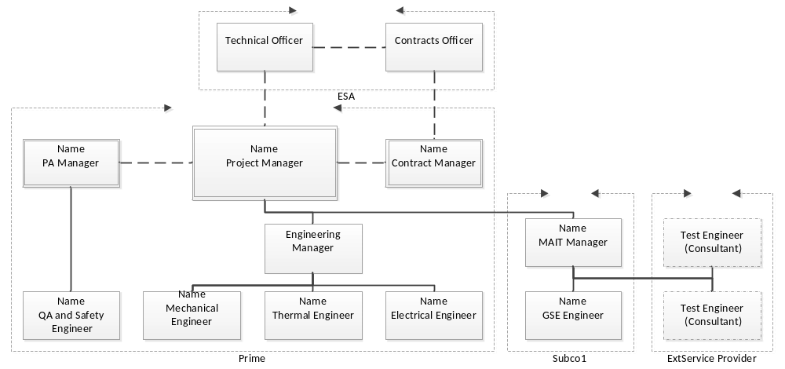

This section is recommended for activities with an ESA price up to 1M€; otherwise, it is mandatory.
The lines of communication and reporting within the project team are as follows: ….
The means for settling disagreements within the project team are: ….

Project Manager
The nominated project manager for the proposed work is ……. They will be responsible for the management and execution of all work to be performed and for the coordination and control of the work within the industrial team.
They will be the official point of contact with the Agency during the execution of the work.

Key Personnel and Their Roles
The key personnel are identified in the table below.

Key personnel
Name | Entity | Project Role | Work Package Manager for
… | … | … | (work package IDs)
… | … | … | …
… | … | … | …
… | … | … | …

The above list of key personnel includes all people who have been assigned work package management responsibilities.
The provisions of Clause 9 of the ESA General Clauses and Conditions for ESA Contracts, as amended in the Draft Contract, will apply to all key personnel.

Qualifications and Experience
The CVs for all key personnel are provided in Annex 1 to this Part of the Proposal. Each CV provides:
- a summary of the work experience of the person concerned;
- a brief description of their present job and responsibilities;
- their specific qualifications and experience of direct relevance to their role in the project.

Time Allocation to the Project
The time allocations of the key personnel to the project are summarised in the table below.
Time allocation of the key personnel to the project
Name | WP …  hours (%) | WP …  hours (%) | WP …  hours (%) | WP …  hours (%) | WP …  hours (%) | Overall  hours (%)
… | 30 (5%) | … | … | … | … | 150 (10%)
… | … | … | … | … | … | …
… | … | … | … | … | … | …
… | … | … | … | … | … | …

Facilities to be used for the Work Proposed
Include this section if facilities are planned to be used in the proposed activities.

List of facilities
The following internal and external facilities are planned to be used in the proposed activity.
Facilities to be used in the proposed activity
Facility ID | Facility Type | Description/ Capabilities | Availability (Internal/External) | Status
1 | RF Test | … | Internal | Existing
2 | … | … | … | …
… | … | … | … | …
… | … | … | … | …
Include the following if external facilities are planned to be used.
The following table provides further details on the external facilities that are planned to be used.
External facility owners and their project roles
Project Resources Template | Facility Owner | Project Role  (Subcontractor/external service provider)
1 | … | …
2 | … | …
… | … | …
… | … | …

Development of the Facilities
No need has been identified for the purchase, development or upgrade of facilities for the proposed activity. The available facilities are considered adequate and complete for this purpose.
or
(delete the inapplicable paragraph)
As identified previously, the following facilities need to be developed for use in the proposed activity.
Details of facility developments
Facility ID | Description of the Development or Modifications | Cost Charged to Contract  (none/ directly/ indirectly)
… | … | …
… | … | …
… | … | …
… | … | …

The facilities are considered adequate and complete for the proposed activity once the developments detailed in the table above have been successfully completed.

Management Plan

General Management Plan
This section is optional for activities with an ESA price up to 1M€.
Include this section only if the proposal includes the Product and Demonstration Phase.
Content Requirements | Phase(s)
4-1 | All

The Tenderer’s management plan is provided in document reference, a copy of which is attached to this proposal. This describes the management control organisation and the processes and procedures for exercising control of the project.

Interfaces with Third Parties
Include this section only if the Proposal includes a Demonstration activity within the Product and Demonstration Phase.
Include the following paragraphs only if the proposal includes a Space Segment or End-to-End System Demonstration activity within the Product and Demonstration Phase.
Our project team will interface with the project team responsible for developing the spacecraft as follows: …….
Our project team will interface with the end customer of the product as follows: …….
Include the following paragraph only if the flight item is an independent case.
Our project team will interface with the entity responsible for operating the product in orbit as follows: …….

Include the following paragraph only if the proposal includes a Ground Segment or End-to-End System Demonstration activity in the Product and Demonstration Phase.
Our project team will interface with the users with whom the product will be evaluated as follows: …….

Product Assurance Plan / Quality Plan
Include this section only if the proposal includes the Product and Demonstration Phase.
The product assurance / quality plan is attached to this proposal. We consider it to be in line with our customer’s quality requirements and commensurate with the current maturity of the product development.

Security Management Plan(s)
Include this section only if the proposal foresees classified or sensitive unclassified developments to be performed during contract execution.

Preliminary Information Security Management Plan [possible Table of Contents]
- Security roles and responsibilities;
- Need-to-Know policy & implementation;
- Security Risk Management Process;
- Information protection implementation plan;
- Equivalence matrix between ESA markings and project/company markings;
- Specific aspects for Unclassified information;
- Specific aspects for Classified information [if applicable];
- ITSEC (INFOSEC) and Cyber-Security;
- Personnel Security;
- Information Security Incident Management.

Preliminary Security Management Plan [possible Table of Contents]
Include this sub-section if the proposal includes the development of classified or sensitive unclassified (e.g., Export Controlled) HW and/or SW.
- Security roles and responsibilities;
- Security characteristics of the product and relevant certification strategy;
- Security Risk Management Process;
- Physical Security;
- Personnel Security;
- Security Operational Procedures;
- Information Security (if not covered in a separate Information Security Management Plan);
- Security Incident Management.

Facility Security Clearance Plan
Include this sub-section only in the following cases:
- the proposal includes developments classified as “ESA CONFIDENTIAL” (or higher);
- the proposal includes developments classified as “ESA RESTRICTED” and the national laws and regulations applicable to the Tenderer / Sub-contractors require a FSC for that level of classification.
The Tenderer and all proposed Sub-contractors already hold a FSC up to the level required for the proposed activity.
OR
[Replace XXXXX below with the maximum level of classification for which the FSC is required for the activity]
We are aware that, pursuant to ESA Security Regulations and the applicable national laws and regulations, a FSC up to the level XXXXX is required, prior to contract award, for the Tenderer and for the Sub-contractors needing to handle classified information/products. In this respect, the following plan applies:
List here — for the Tenderer and for any proposed Sub-contractors needing to handle classified information/products — the plan for achieving the FSC from the respective NSA/DSA, including the expected clearance date and a short schedule/progress report to justify it.

- Curricula Vitae of the Key Personnel
Provide completed CVs for all members of the key personnel using the following template, or equivalent shall be uploaded separately into a dedicated section of ESA-Star.
Name
Specific Qualifications and Experience Relevant to the Project Role: | …
Entity: | …
Present Position and Responsibilities in the Entity: | …
Education:
Year(s) | Educational details
Year(s) | Educational details
Work Experience:
Year(s) | Entity, Project, Position, Responsibilities, Achievements
Year(s) | …
Year(s) | …

- Requirements for Proposal Content
Requirement | Template Section
- The Tenderer shall present its management plans, policies and procedures for this activity, including:  - A description of the management control organisation.  - The procedures that will be used to exercise control over the project.  - The Subcontractor control procedures.  - Internal review processes.  - Escalation process for internal issues.  - Escalation process for risk management.  - Escalation process for cost management.  - Escalation process for schedule management.  - Progress reporting.  - Configuration management. | Section 11  Management Plan

Actual or anticipated dates.
Percentage time allocations for work packages are expressed relative to the total man-hours of all personnel contributing to that work package. For the overall time allocation, it is the percentage of the individual’s time that is dedicated to the project, i.e. the ratio of the total number of hours spent on the project and the total number of hours worked over the planned project duration.
For example, hardware, software, manufacturing equipment, test equipment, production and integration lines.
For example, “existing”, “requires modification”, “still to be developed/built”, “purchased”.

